Phase 1 – Testing Report

Project: Flood Damage Claim Assessment System

1. Objective

The objective of testing is to verify that the system correctly creates flood damage claims, rejects invalid inputs, prevents duplicate claim IDs, and displays the correct total number of claims.

2. Test Cases

Test Case| Test Input| Expected Result| Actual Result| Status
Valid Claim Creation| ID: 101, Name: Rahul Sharma, Type: House, Amount: 15000| Claim created successfully| Claim created successfully| PASS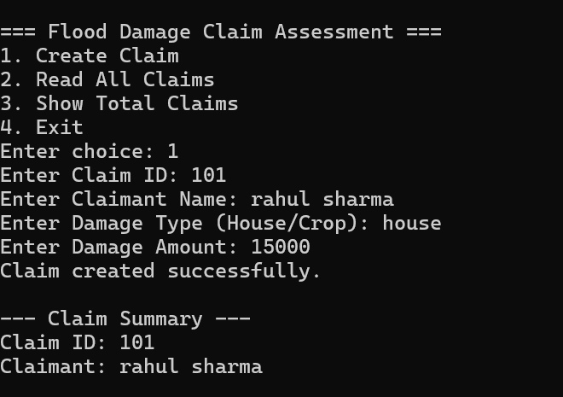
Duplicate Claim ID| ID: 101 entered again| Duplicate ID rejected| Duplicate ID rejected| PASS
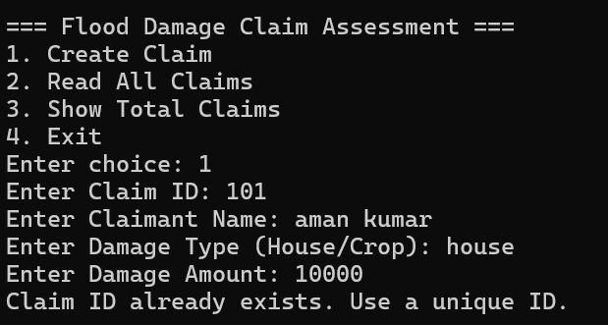
Invalid Damage Type| Type: Water| Invalid details message| Invalid details message| PASS
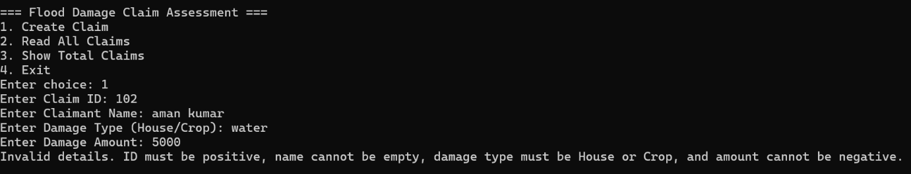
Negative Damage Amount| Amount: -5000| Invalid details message| Invalid details message| PASS
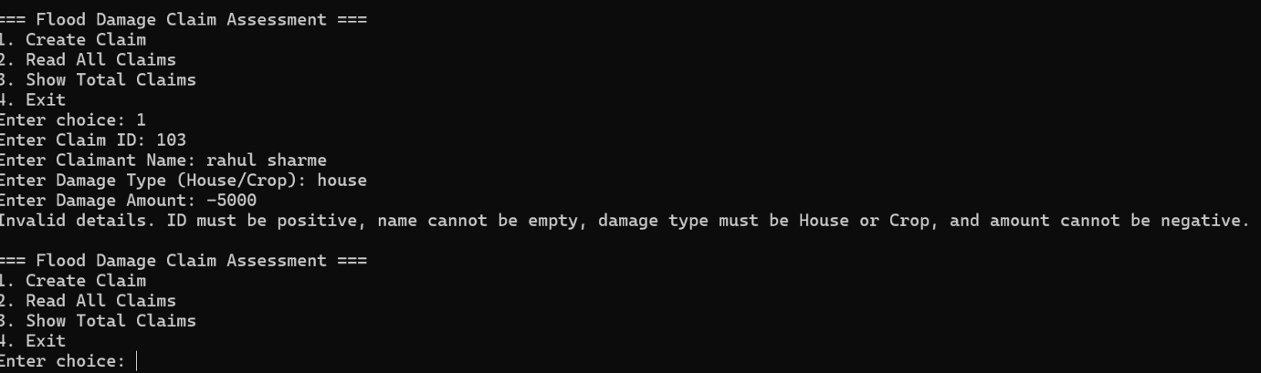
Total Claims Count| Menu option 3| Total claims displayed as 1| Total claims displayed as 1| PASS
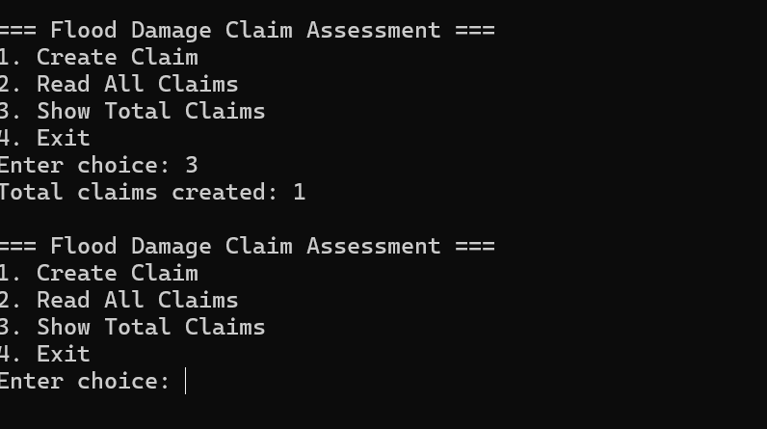

3. Testing Conclusion

All five test cases passed successfully. The system correctly creates valid claims, rejects duplicate claim IDs, validates damage types and damage amounts, and displays the total number of successfully created claims.

4. Evidence

Attach the five screenshots captured during testing as evidence for the corresponding test cases.

